**Archer Shooter**

# How to play

1. Before running the game, add the "main" and "gameMission" scenes in the folder scene to the "scenes in build" column of the "build settings" interface.
2. set the gravity value to be "-3".

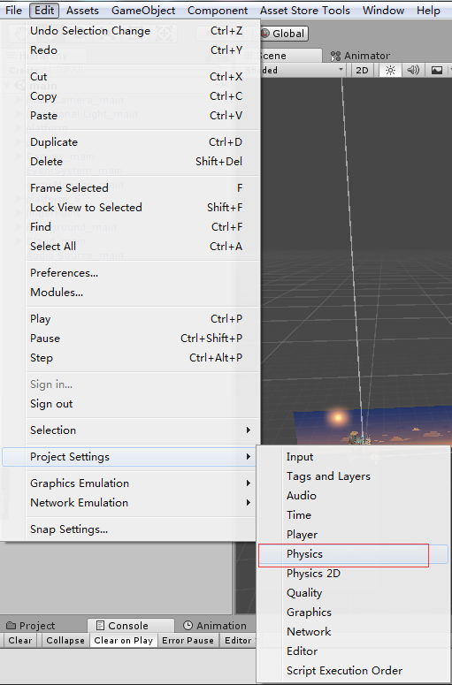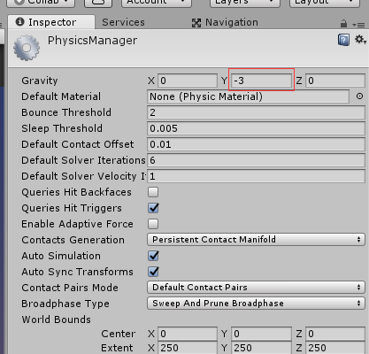

1. select the "main" scenario and start the game.

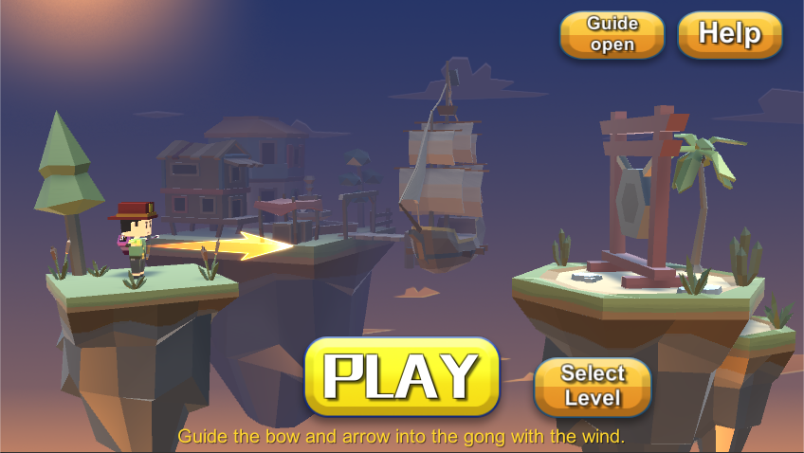

1.  The boot switch guides the player to slide fingers on the screen to create the wind.
2.  Game play tutorial
3. 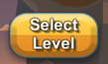 Level selection, open checkpoint selection interface

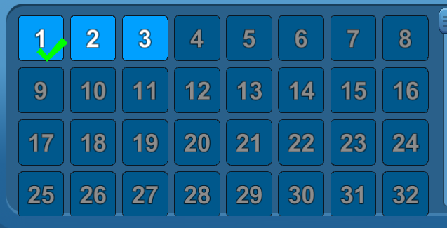

1.  Directly clicking the "PLAY" button will continue the game from the last checkpoint.
2. choose the gateway to enter the game.

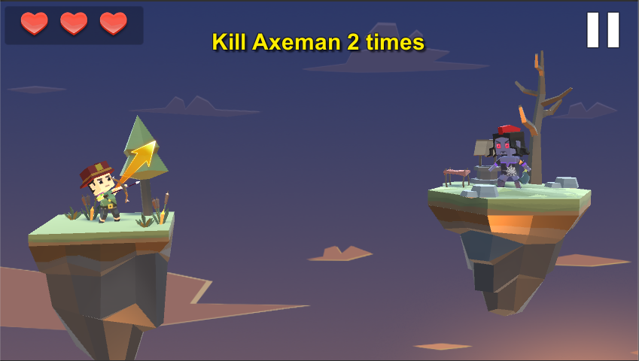

1.  Player blood volume, three hearts all disappear, game ends
2.  Checkpoint target
3. After starting the game, by clicking and dragging the mouse to create the wind in the game, the wind can affect the player's bow and arrow flight direction, the player needs to guide the bow and arrow hit the target through the wind.

# Advanced Scripts

atkObjS.cs: Weapon attack judgement

btncontrol.cs: Button function of level selection interface

control.cs: Protagonist control

controlWind.cs: Create the wind

destroyBox.cs: Remove useless objects from the scene

enemy.cs: Enemy AI control

existTime.cs: Special effects are removed.

gameManage.cs: Main function control of game

mainManage.cs: Main interface main function control

smoothFollow.cs: Camera following

sound.cs: Placed in the "Animator Controller", used for the role play corresponding audio playback.

soundResources.cs: Voice playback control

wind.cs: Functional control of wind

# Make your own game

## Basic function control of game

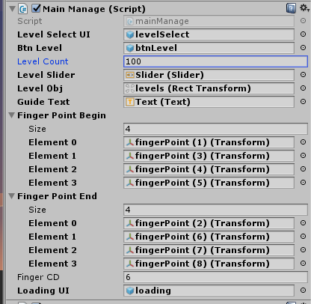

1.  Level setting
2. 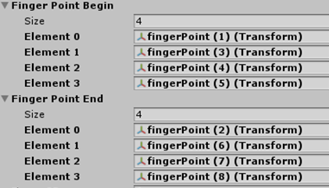 In the main interface, guide the starting point and ending point of the animation, and combine the random start point with the random ending point.
3.  Boot animation interval

## Task goals for each level

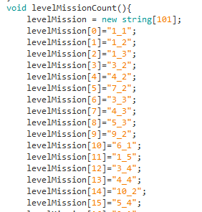

There are 12 kinds of mission objectives, and the number of mission objectives can be set freely.

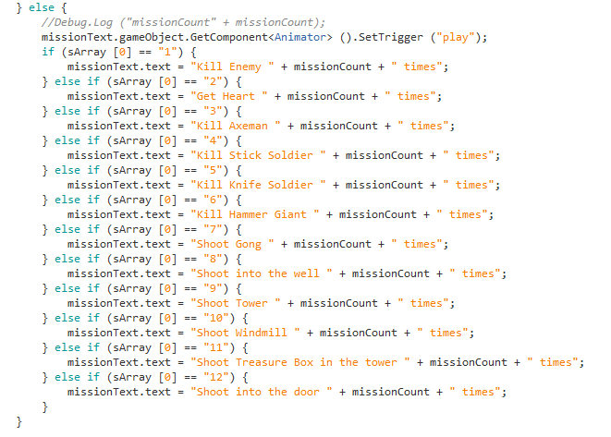

# **How to get support**

Contact to us ：soyskyapple@outlook.com

Remember attach your invoice otherwise there would not be my reply.

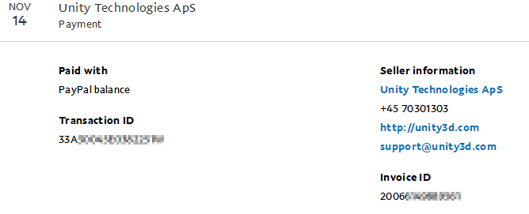

The invoice you can get from your paypal account records.

If you do not have a invoice. Grab some screenshot to confirm your buy successful flow is also ok.